How to Use Google Classroom on a Computer or a Laptop

- Open an internet browser. Google Chrome is best but any will work.
- Type into the top bar classroom.google.com.
- When you first use Google Classroom, once logged in, it will ask if you are a student or a teacher. Click Student.
- When you first log in, you will need to accept the invitation to join the class by clicking ‘join’. You will not need to do this after the first time.
Click here.
- This will take the children to their class page.
On the ‘Stream’ it will show the announcements from the class teacher. They will tell the children what lessons they will have that day and what time their live lessons are.
‘Classwork’ will show all of their assignments that are due and what they have handed in. The assignments will also appear on the stream.

- Assignments will be a bright colour and will turn grey once they have been handed in.
- Click on the assignment to read the teacher’s instructions.
- If the work is to be completed on Google Docs (a Google version of Microsoft Word), the teacher may have already added a Google Doc that they want the child to complete. They may have included a picture or table on that Doc ready for the child.
Click here.
When using Google Docs, once the child has finished the work there is a button at the top right hand corner that says ‘Turn in’. They can either press that button or close the tab and click ‘Hand in’ on the assignment page.

- If the teacher wishes the child to use Google Slides (a Google version of Microsoft PowerPoint), the child will need to click on the ‘Add or create’ box and then select Google Slides. They also have the option to upload a file if they want to add a picture or if they have chosen to complete it on Microsoft PowerPoint.

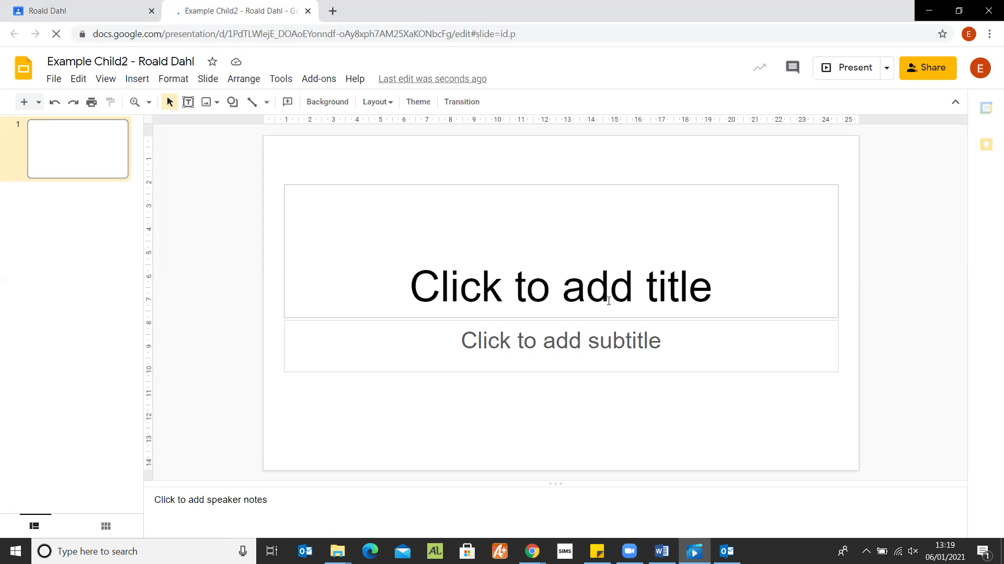Once they have completed their Google Slide, close the tab and click on ‘Hand in’ and then it again will ask for your confirmation if you want to ‘Hand in’. All Google Apps automatically save the work so no pressing save is needed and work will not be lost.
- If your child needs support from their teacher, or wants to ask a question, on an assignment they have the option to write a private comment to the class teacher. This is also where a class teacher will give feedback on some of their pieces of work.

- If the class teacher has set the child work on Google Forms, this will open in a new tab. There will be a range of options for the children to complete the form. Once they have submitted the form, some will have been set up to give the child instant feedback on what questions were correct and which were incorrect with the correct answer displayed below theirs. Sometimes a teacher may have missed a possible way to write an answer by a child. Therefore, the answers will be checked by the class teacher and amended if the child had given a possible correct answer.

- If you click on the ‘Waffle’ at the top right-hand corner of the page, you can see all of the Google Apps available. Children can use this to create their own Docs, Slides, access the Google Classroom or go to Google Drive.
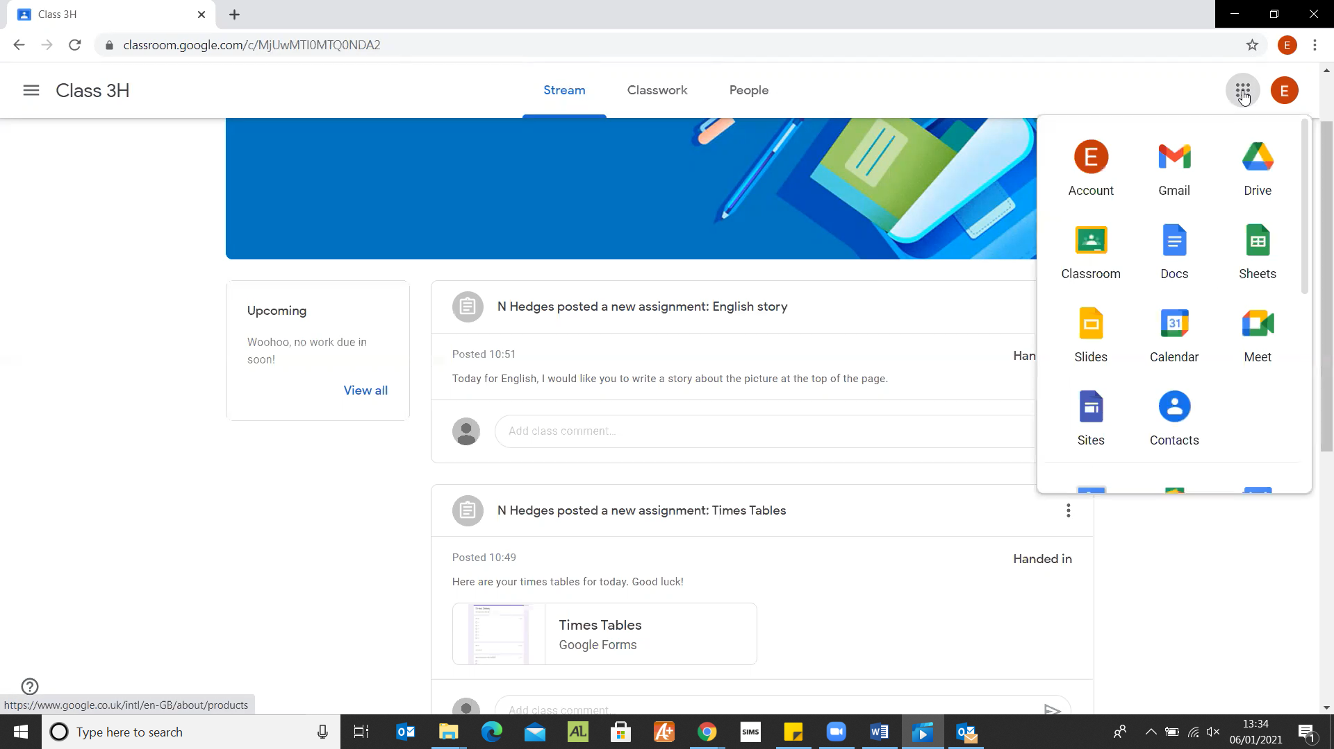

- Google Drive is where all of the child’s work is kept. They can create their own folders as well as make additional Google Docs or Google Slides. If they click ‘Share’ when on the Doc or Slide, they can then search for their teacher’s email to share the work with them.
- If they right-click or click on the ‘+ New’ button, they can create a folder, Doc or Slide.

