Overview of Google Apps

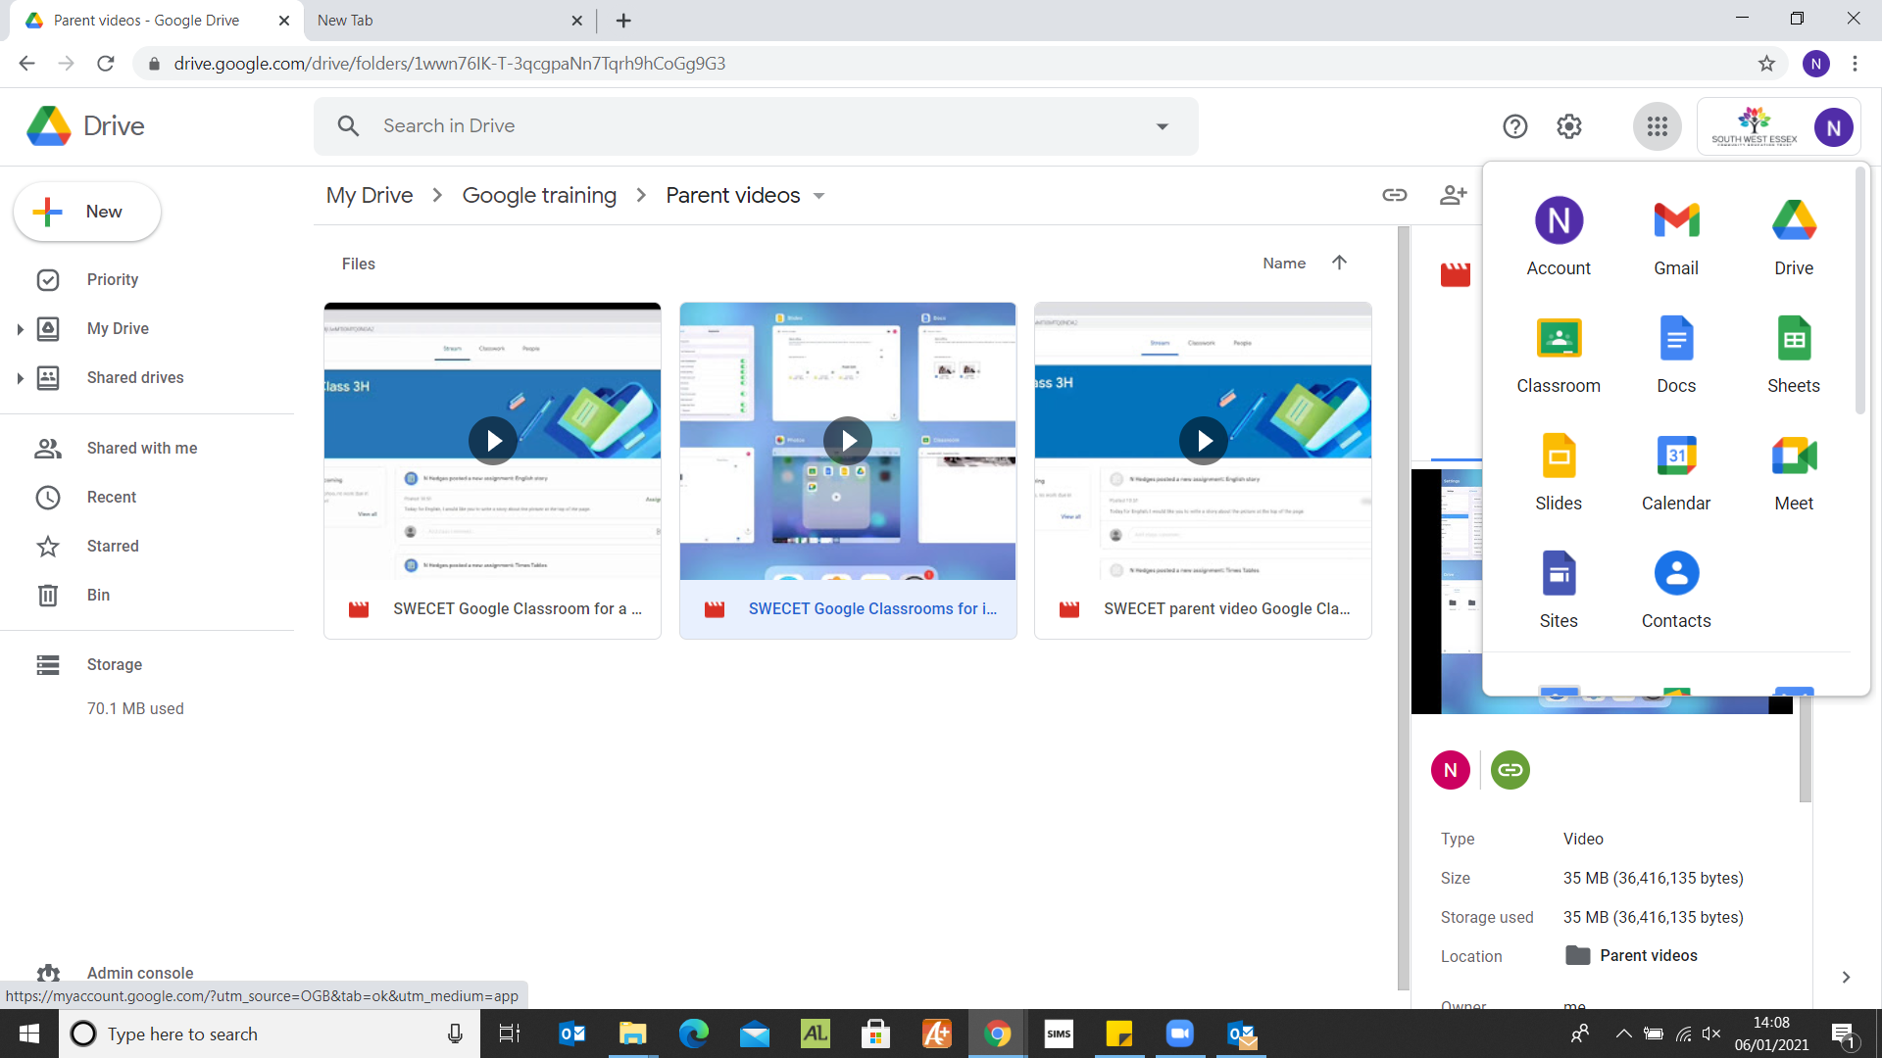

Google Drive

This is where children can store all their work and create new Google Docs and Google Slides.



Google Classroom

This is where children will see their teacher’s posts for what the daily work is and post their live lesson link.



Google Docs

This is a Google version of Microsoft Word.



Google Slides

This is a Google version of Microsoft PowerPoint.



Google Meet

This is where the live lessons for the children will take place.

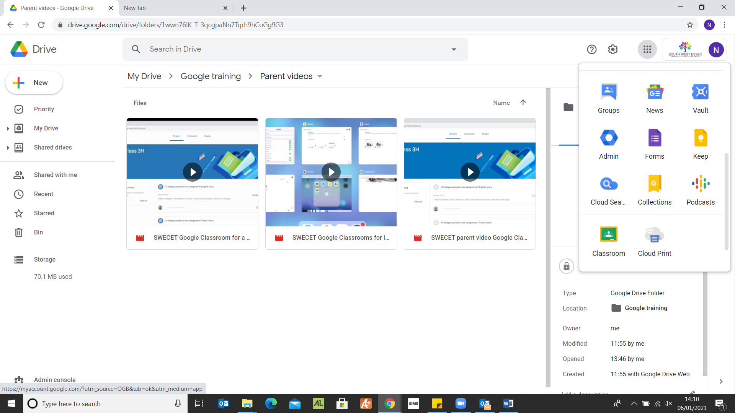

Google Form

This is where children can complete questions set by the teacher. Some of these will give instant feedback to the children.