Day 1
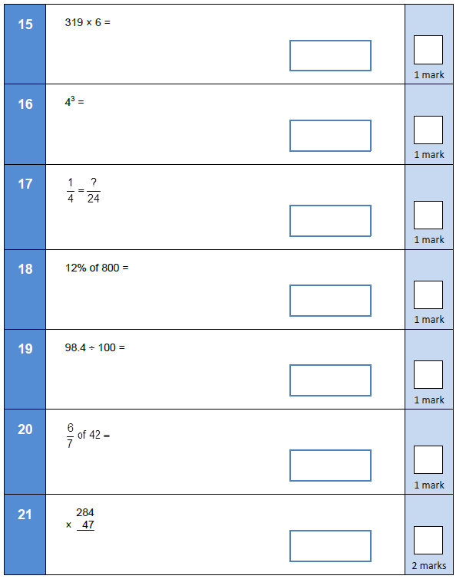

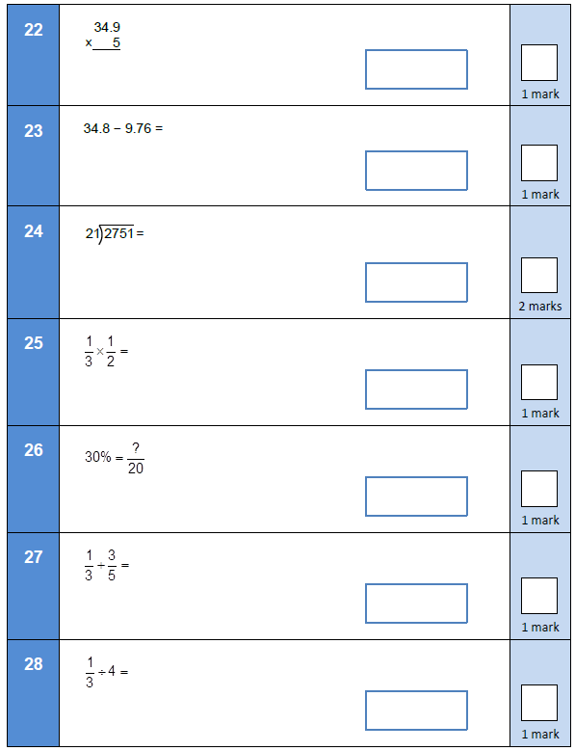

Answers
- 1914
- 64
- 6
- 96
- 0.984
- 36
- 13,348
- 174.5
- 25.04
- 131
- 1/6
- 6
- 14/15
- 1/12

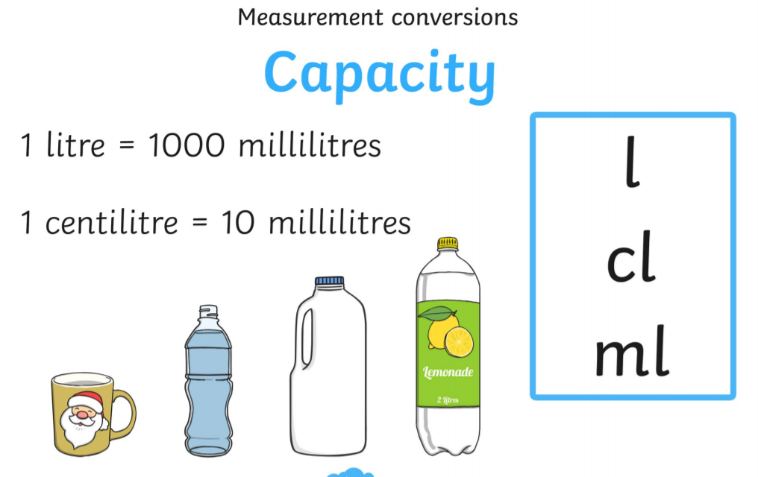
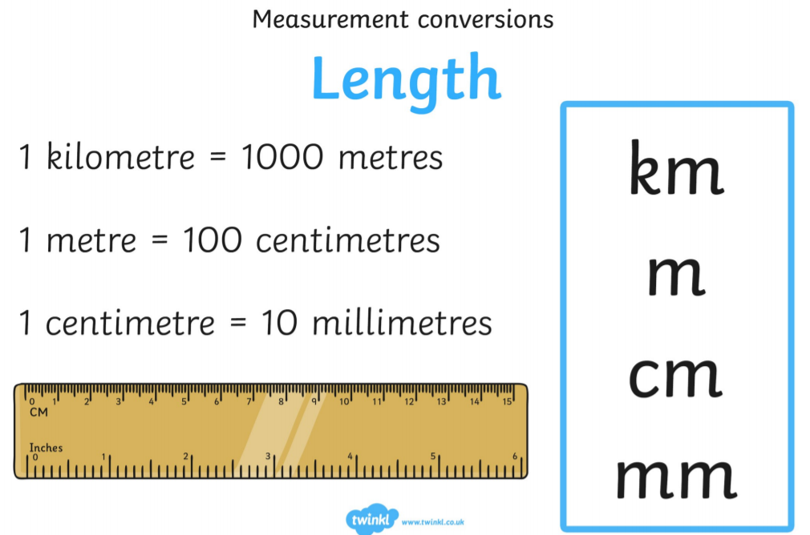
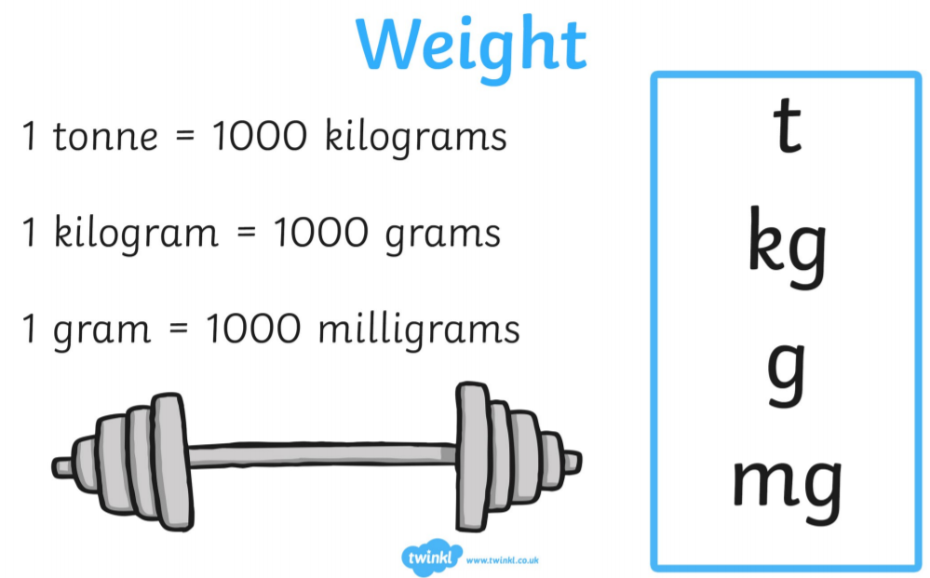

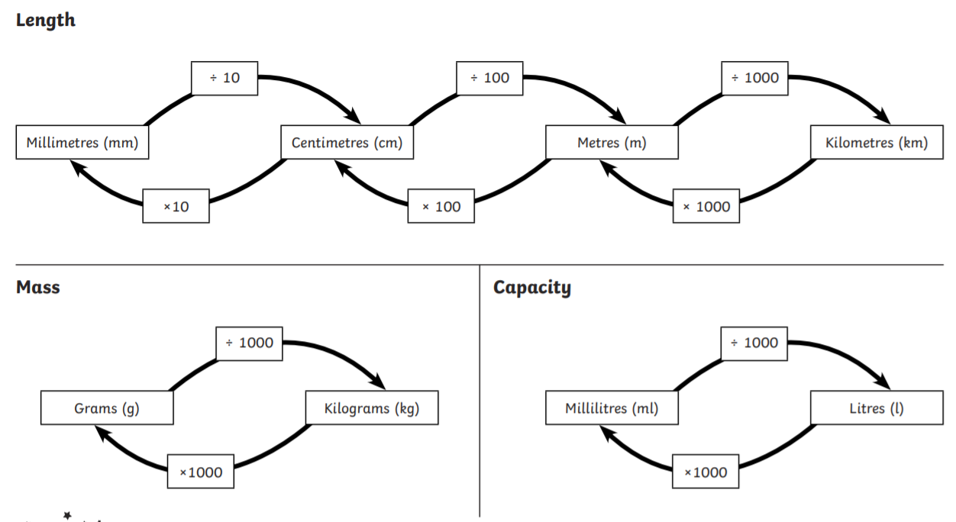

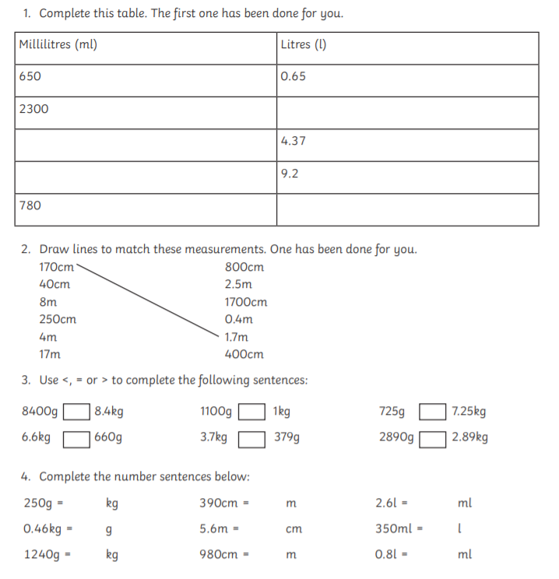

- 2.3litres, 4370ml, 9200ml, 0.78litres

- 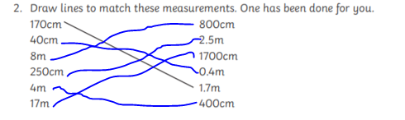
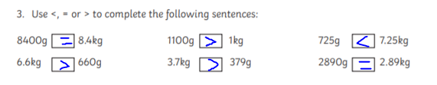

- 0,25kg 3.9m 2600ml
460g 560cm 0.35litres
1.24kg 9.8m 800ml

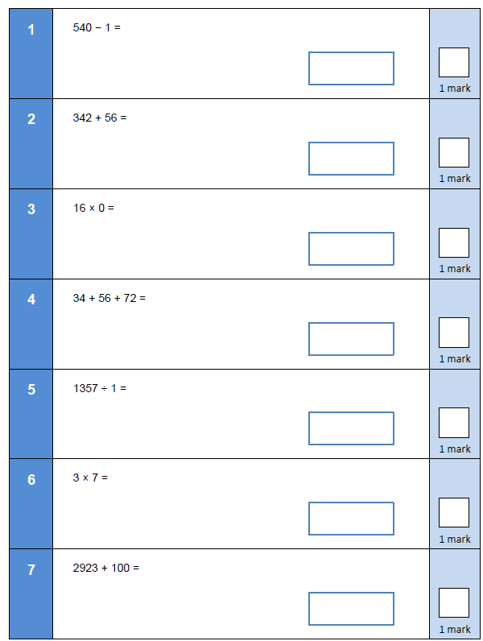
Day 2

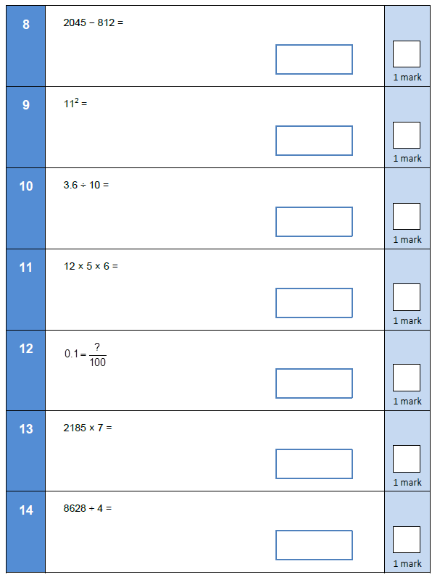

Answers
- 539
- 398
- 0
- 162
- 1357
- 21
- 1023
- 1233
- 121
- 0.36
- 360
- 10
- 15,295
- 2157

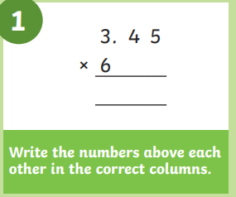

2. Drop the decimal down to the bottom.

3.45
X 6
.

Then continue with your usual multiplication.

- 6.8 x 4
- 5.4 x 7
- 38.28 x 3
- 45.74 x 6

- Tickets for a show cost £23.67. How much do seven tickets cost?

- The booking fee for each ticket is £2.75. What is the total price for all seven tickets including the booking fee?

- Steven manages to save £543.53 every year. How much does Steven manage to save over six years?
- Karen bought five cans of food for £1.99 each, and seven cans of food for £1.28 each. What was the total?

- Jim bought eight cans of each of three different kinds of cat food. One kind cost £1.25, the second kind cost £1.64, and the third kind cost £0.79. What was the total cost?

- Jerry bought five boxes of nails for £4.58 and seven boxes of screws for £2.83. What was his change from £100?

Answers
- 27.1
- 37.8
- 114.84
- 274.44
- £165.69
- £184.94
- £32.61
- £18.91
- £92.59

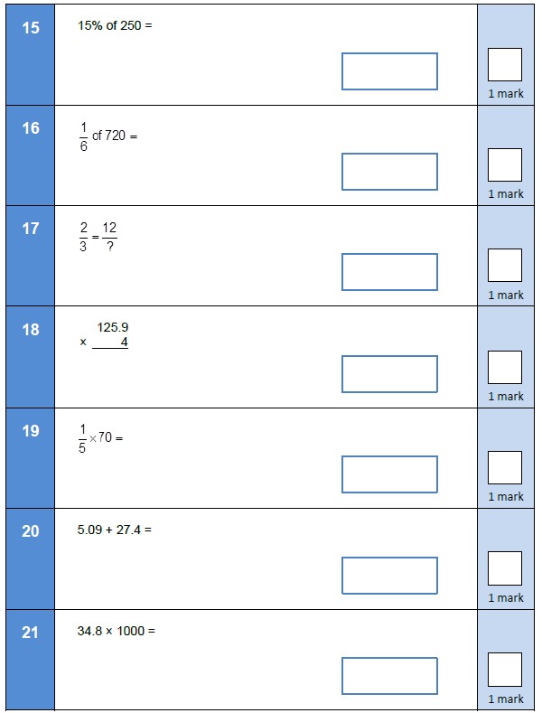
Day 3

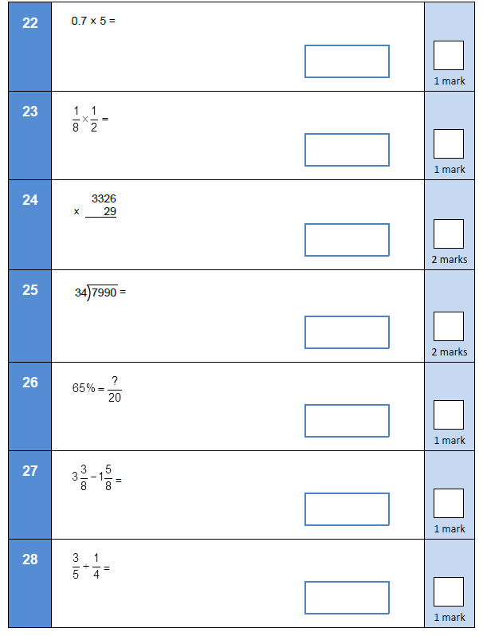

Answers
15. 37.5
16. 120
17. 12/18
18. 503.6
19. 14
20. 32.49
21.34800
22. 3.5
23. 1/16
24. 96,454
25. 235
26. 13/20
27 14/8 or 1 and 6/8
28. 12/20

Algebra
Remember!!
A letter is like a ?
If a letter is next to a number, it means multiply
3a = 3 x ?

3a+ 4 = 10 really means 3 x ? + 4 = 10
Begin with the inverse
10 – 4 = 6
6 ÷ 3 = 2
Therefore, a = 2
Check! Substitute it back into the equation
3x2 + 4 = 10 6 + 4 = 10

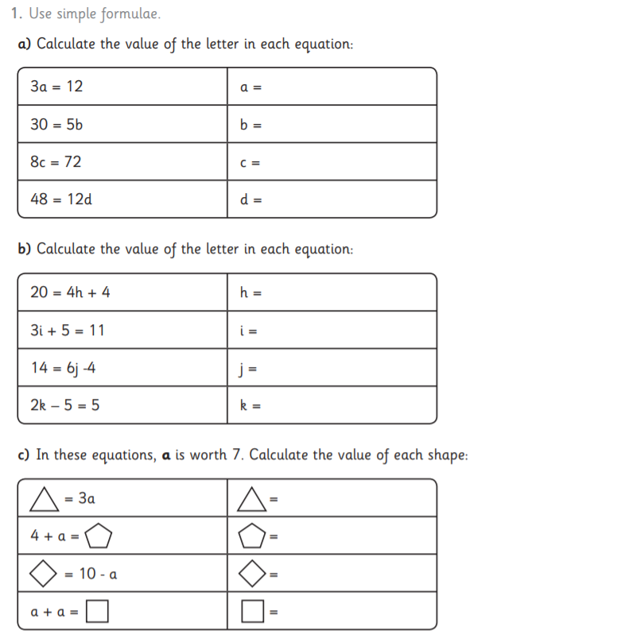
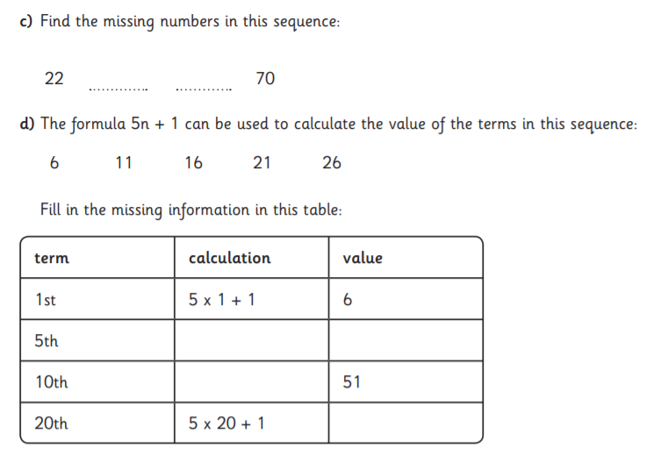
3
2
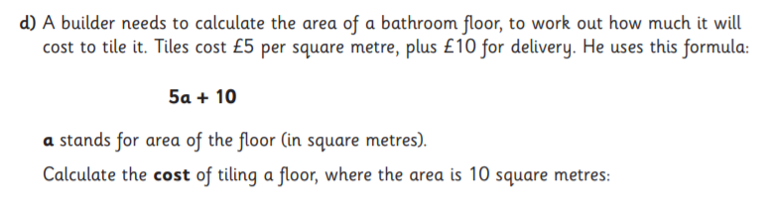

Answers
- A = 4
B = 6
C = 9
D = 4
H = 4
I = 2
J = 3
K = 5

Triangle = 7
Pentagon = 11
Diamond = 3
Square = 14

- C = 38 amd 54
Term | Calculation | Value
1st | 5 x 1 + 1 | 6
5th | 5 x 5 + 1 | 26
10th | 5 x 10 + 1 | 51
20th | 5 x 20 + 1 | 101

- £60
Day 4
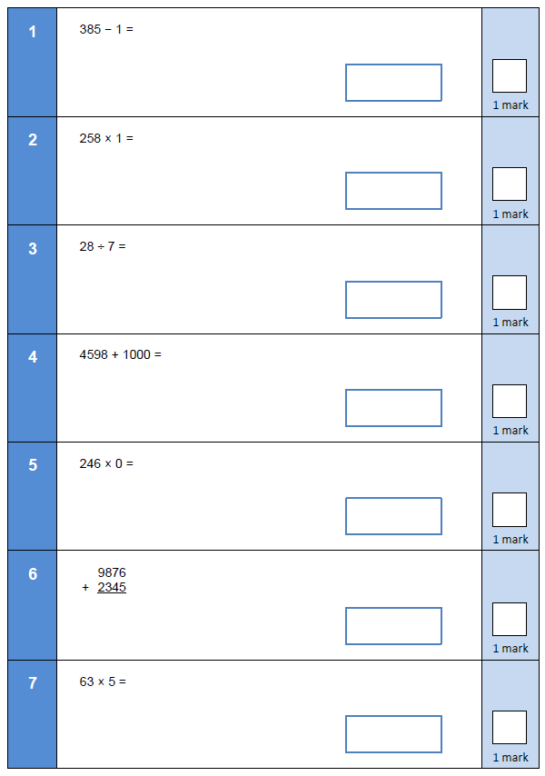

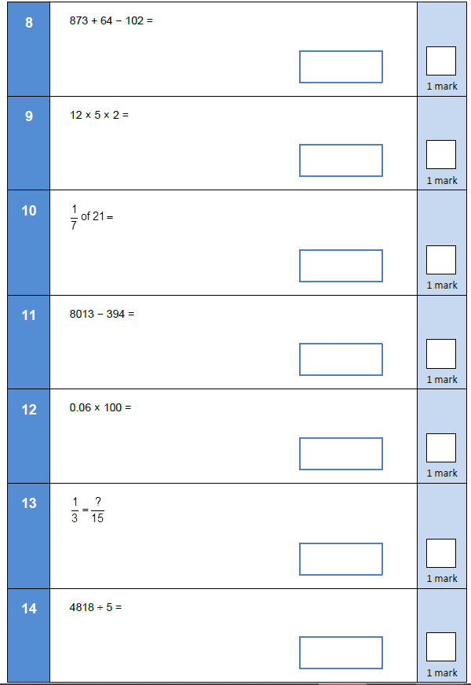

Answers

- 384
- 258
- 4
- 5598
- 0
- 12221
- 315
- 835
- 120
- 3
- 7619
- 6
- 5/15
- 963r3

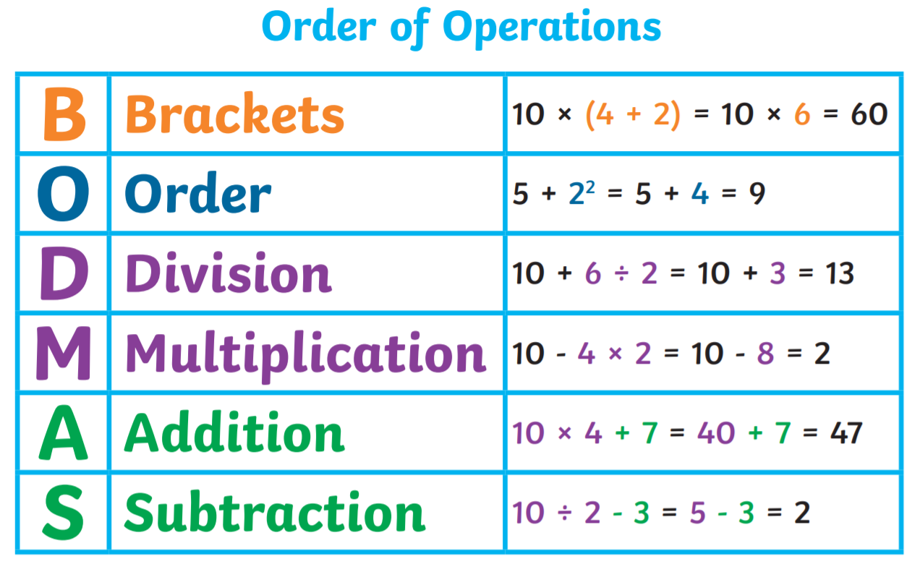
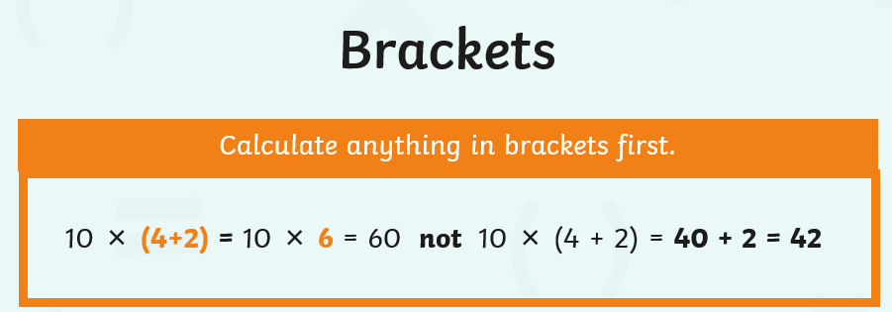

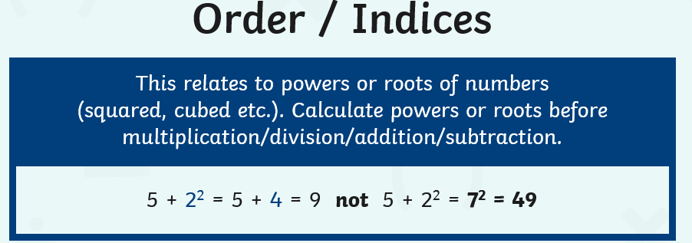
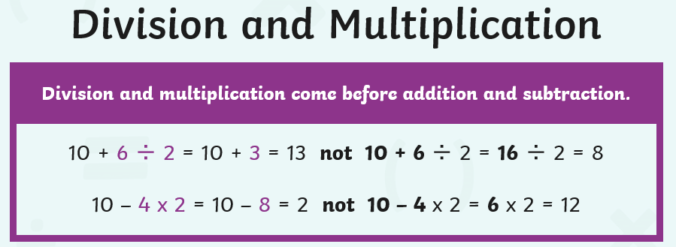

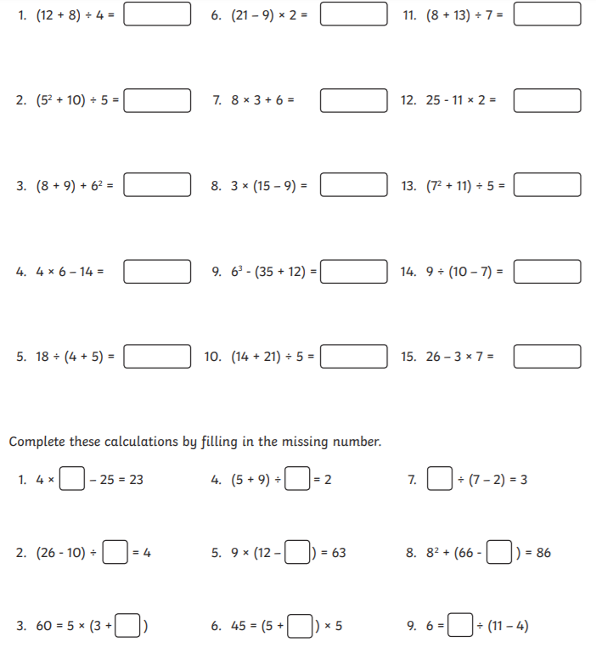
Answers
- 5
- 7
- 53
- 10
- 2
- 24
- 30
- 18
- 164
- 7
- 3
- 3
- 12
- 3
- 5
Missing numbers
- 12
- 4
- 9
- 7
- 5
- 4
- 15
- 44
- 42

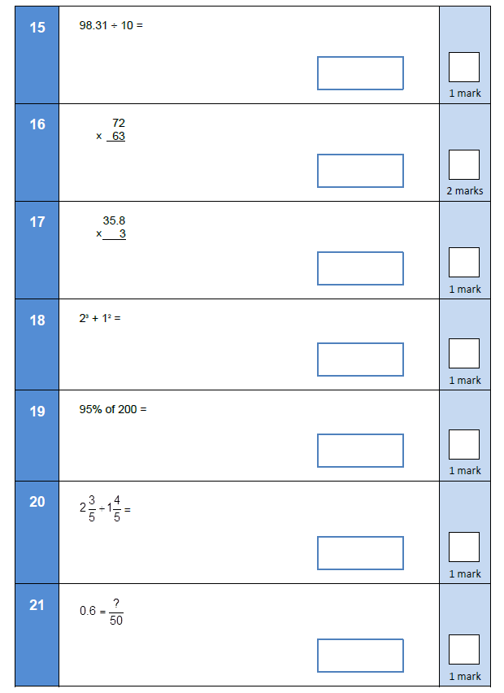
Day 5

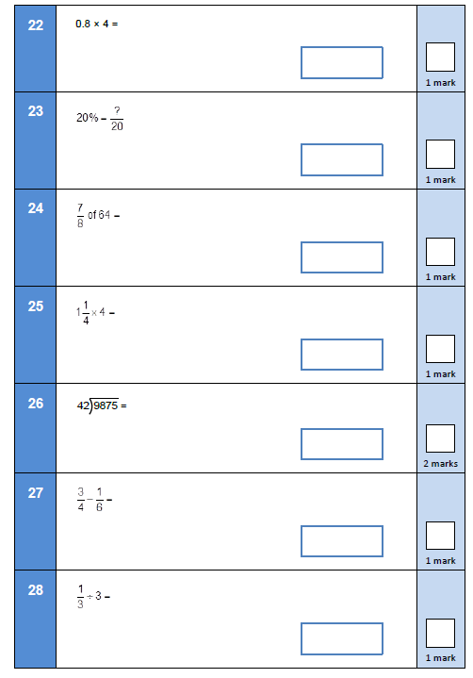

Answers

- 9.831
- 4536
- 107.4
- 9
- 190
- 4 and 2/5
- 30/50
- 3.2
- 4/20
- 56
- 5
- 235 r 5
- 7/12
- 1/9

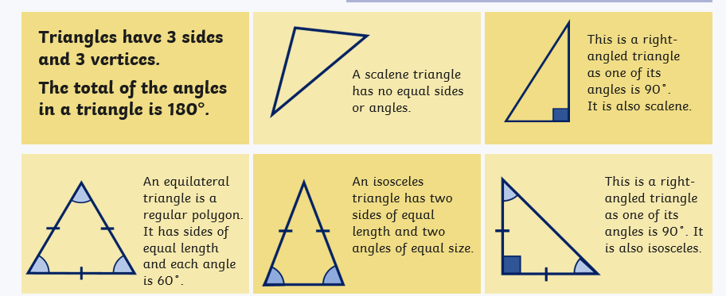

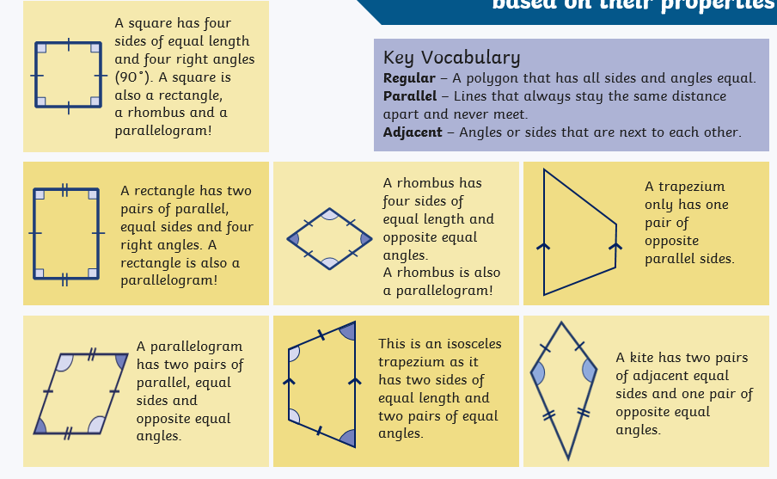

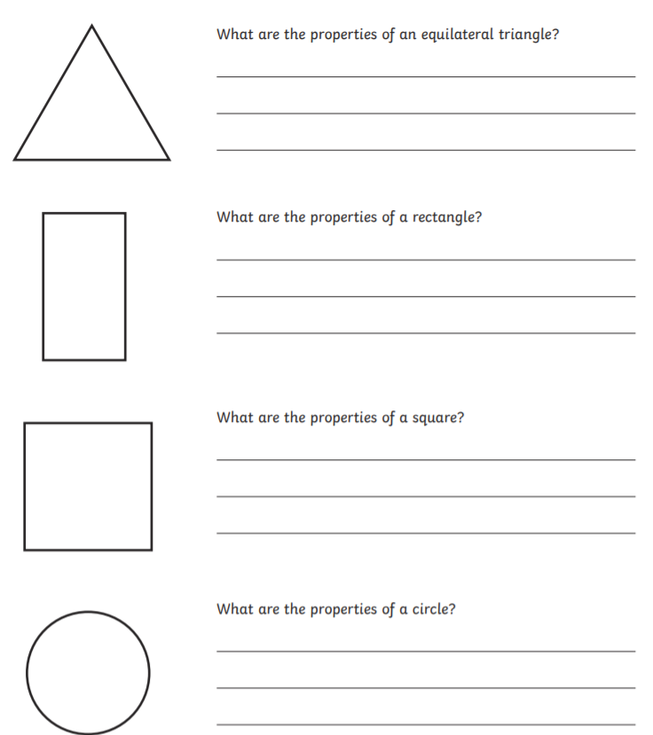

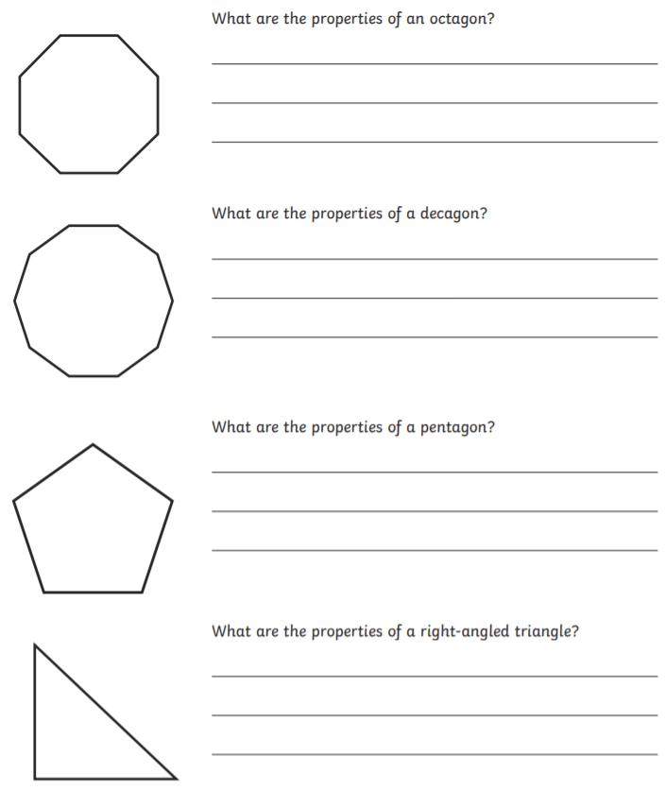

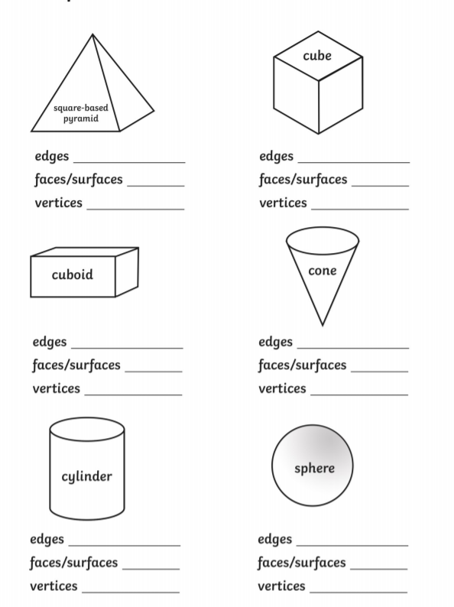

Answers

Equilateral triangle – All sides of equal length and all interior angles are 60 degrees.
Rectangle – Has two pairs of parallel lines which are equal in length. All interior angles are right angles (90)
Square – All sides are equal length and all interior angles are right angles (90)
Circle – A circle has no interior angles and has one curved side.
Octagon – Has 8 equal sides and all interior angles are 135 degrees.
Decagon – Has 10 equal sides in length and each interior angle is 144 degreee.
Pentagon – Has 5 equal sides in length and each interior angle is 108 degrees.
Right-angled triangle – On angle is 90 degrees. Two sides are of equal length and the other two angles are also equal in size.

Square based pyramid
Edges = 8
Faces/Surfaces = 5
Vertices = 5

Cube
Edges = 12
Faces/Surfaces = 6
Vertices = 8
Cuboid
Edges = 12
Faces/Surfaces = 6
Vertices = 8

Cone
Edges = 1
Faces/Surfaces = 2
Vertices = 1

Cylinder
Edges = 2
Faces/Surfaces = 3
Vertices = 0
Sphere
Edges = 0
Faces/Surfaces = 1
Vertices = 0

