Monday - RUBBISH
They had seen the piece of chain lying in a heap of rubbish in the scrap yard a few days previously. It was just what they needed to complete the camp they had made – to secure the door and keep those not in the group out. All that was required was for one of them to climb the wire mesh fence, drop into the yard and retrieve it.
All eyes were on Josh, who was a tall, strong boy with an athletic body and straight, brown floppy hair.
“Go on, Josh, you could do it easily,” they urged him.
He didn’t want to; he knew it was wrong, but he also knew he would get no peace until he did.
Keeping his toes in the small mesh holes was tricky; however, he was soon at the top and dropping down to the ground into a crouch. It was as he landed that he heard it . . . a faint growl that swiftly grew to a furious barking. As he dived behind an old, wrecked van, he heard footsteps and then an angry voice shouted at his friends,
“Clear off out of here the lot of you! If I see you hanging round again, I’ll let the dog loose on you.”
There was laughter and running footsteps . . . . then silence.
Not knowing where the man was, Josh edged round the other side of the van where he had a good view of the site office. He could see a small room with two men. No, wait, was that a third on the floor? Something was wriggling and appeared tied up like a parcel with lots of tape. The voices were muffled but Josh could just make out what they were saying.
“If we’re going to do it, we better get on with it.”
“Where will we dispose of it?”
“Weighed down in the quarry, it’ll never be found.”
At that moment a man (it must have been the one who had chased away the other children) arrived blocking Josh’s view of the proceedings. He was happy not to see and soon wished he was deaf.
Not long later, a car started and Josh crept closer to the gateway. As it opened and the car left, he sprinted out, pursued by the sound of barking and shouting as they realised his presence. He ran for his life, dodging down streets, and as he ran, thought about what to do if he escaped without being caught.

Rubbish Questions
- Where was the chain? (2)
- What surrounded the scrap yard? (1)
- Why did they want the chain? (1)
- Why did the gang think Josh could easily get over the fence? (3)
- Why didn’t he want to do it? (1)
- Why did he do it? (1)
- How do you know the dog was chained? (2)
- What do you think was on the floor and why? (2)
- Why do you think it says ‘he soon wished he was deaf’? (2)
- What do you think Josh should do if he escapes and why? (3)
Why do you think the text was called Rubbish?

Rubbish Questions – Answers
- Where was the chain? (2) Lying in a heap of rubbish in the scrap yard
- What surrounded the scrap yard? (1) Wire mesh fence
- Why did they want the chain? (1) To complete the camp- secure the door and keep those not in the group out.
- Why did the gang think Josh could easily get over the fence? (3) They thought Josh could easily get over the fence because in the text it says Josh, who was a tall, strong boy with an athletic body meaning he is most able to be able to climb the fence.
- Why didn’t he want to do it? (1) Because he knew it was wrong
- Why did he do it? (1) Because he knew he would get no peace until he did
- How do you know the dog was chained? (2) I know the dog was chained as in the text it says I’ll let the dog loose on you, showing that the dog was chained up.
- What do you think was on the floor and why? (2) A person, because in the text it says no wait, was that a third on the floor, referring the amount of men in the room.
- Why do you think it says ‘he soon wished he was deaf’? (2) I think he wished he was deaf because he didn’t want to hear what the men were saying.
- What do you think Josh should do if he escapes and why? (3) If Josh escapes I think he should tell the police because there is another person with the men and from what they’re saying it sounds like they are trying to hide something in the quarry.
- Why do you think the text was called Rubbish? I think the text was called Rubbish as it is set in a scrapyard where there is usually rubbish.

Tuesday - THE SOUND OF BREAKING GLASS
Mum had told us numerous times not to play football in the garden; it damaged the plants and our slide tackles and kicking divots ruined the lawn apparently, although what was the garden for if not having fun in? Swingball was really boring after a bit and Sammy was useless at it. We were too old now for silly swings and climbing frames and the baseball hoop was only fun for a few minutes of shooting.
So it was, on that cold, February morning that we were playing the cup final at Wembley – Liverpool against Manchester United – with MU (me of course) in the lead by four goals to nil when it happened. I dribbled the ball round the budding, rhododendron bush; through the ramshackle, wooden trellis and sprinted down the lawn for a shot at goal where Sam stood, arms outstretched. As my right foot connected, my left foot slipped from under me and I got right under the ball lifting it high into the air as I banged onto my bottom on the lawn.
It was like watching a slow motion film as Sam and I – mouths agape – saw the ball arc into the air, sail over the fence and into the upstairs window of our neighbours’ house. The trouble was, the window was closed! The sound was terrible – a sort of crash, following by the clinking and tinkling of glass shattering and raining down onto the windowsill.
“Quick! Let’s hide! They’ll n ..n.. never kn..n..n..ow it was us.” Sam stuttered.
“You idiot! Of course they will,” I shouted back whilst getting to my feet and trying to think what repercussions might come of this dreadful deed.
At that moment, my neighbour screamed; a sound as awful as that of the breaking glass and frightening similar in that like a firework it burst upon the sky and then sparkled and flashed as it slowly died away.
It was time to face the music. Putting my arm around Sammy’s shoulders, I marched him inside reassuring him as we went,
“Don’t worry Sam, this one was all me. You’ll just cop it for playing football in the garden.”
He was a sensitive boy, my brother, and tears were already sliding slowing down his cheeks like drops down the window pane. He couldn’t help it; he was just someone who felt things deeply, had a vivid imagination and thought things through a lot. I on the other hand thought mostly about myself and like to get on with things without delving too deeply.
“Mum ……. er, I’ve got something I need to tell you, Mum,” I began but got no further as, at that moment, the front door bell rang furiously and continuously.
What happened next soured relations between ourselves and the neighbours until they moved last year; not that that mattered much to myself and Sammy. What we cared more about was the pocket money that went towards replacing the window and the fact that the lawn was replaced by paving stones!

THE SOUND OF BREAKING GLASS Questions

1. Why was football not allowed in the garden? (2)
2. What activities were on offer? (2)
3. Where were the boys playing their 'cup final'? (1)
4. What simile is used for watching the ball break the window? (1)
5. Are clinking and tinkling good verbs for the glass breaking and why? (1)
6. What might the boy have been thinking as he sat on the lawn watching the glass break? (3)
7. What does the boy mean when he says, "You idiot! Of course they will."
8. Why does the author compare the sound of breaking glass and the neighbour screaming to a firework? Explain your answer. (3)
9. What figure of speech is, "It was time to face the music." and what does it mean in this context? (2)
10. Compare what we find out about the two brothers and their characters. (3)
11. What were the results of the accident? (3)

THE SOUND OF BREAKING GLASS Questions answers

1. Why was football not allowed in the garden? (2) it damaged the plants and our slide tackles and kicking divots ruined the lawn
2. What activities were on offer? (2) Swingball, swings and climbing frames and the baseball hoop
3. Where were the boys playing their 'cup final'? (1) Wembley
4. What simile is used for watching the ball break the window? (1) like watching a slow motion film
5. Are clinking and tinkling good verbs for the glass breaking and why? (1) Yes as they help you to imagine what the sound is like.
6. What might the boy have been thinking as he sat on the lawn watching the glass break? (3) I think the boy would be very worried about what the punishment might be as in the text It says trying to think what repercussions might come of this dreadful deed, showing that he is worried about what might happen to him.
7. What does the boy mean when he says, "You idiot! Of course they will." He means that it is obvious who broke the glass.
8. Why does the author compare the sound of breaking glass and the neighbour screaming to a firework? Explain your answer. (3) I think the author compares the breaking glass and the neighbour screaming to being like a firework as the sound of a firework is very loud and striking, you cannot miss it and it is very high pitched, meaning that others around them would also hear and it emphasis how bad their actions are.
9. What figure of speech is, "It was time to face the music." and what does it mean in this context? (2) It means to go and face the consequences.
10. Compare what we find out about the two brothers and their characters. (3) One is a sensitive boy, who feels things deeply, and had a vivid imagination and thinks things through a lot. On the other hand, the other brother thought mostly about himself and liked to get on with things without delving too deeply.
11. What were the results of the accident? (3) Their relationship with their neighbours was not the same again and their pocket money was used to replace the window and the lawn was replaced with paving stones.

Wednesday - DEEP WATER

As I sat in silence on the river bank, I felt the breeze gently teasing my brown floppy locks and whispering gently in my ear as if to soothe my aching heart. The whole beautiful valley - the warm sun and the river weaving its winding path like a snake slithering endlessly through the peaceful landscape - seemed to wrap my whole body in cotton wool, numbing the torment in my mind.
Fishing had always been an escape from reality, from the first time my father had brought me to this perfect place and taught me to cast out the rod; a smooth, curling roll behind followed by a flick of the wrist to bring the long line in a graceful arc over my head, the spinner landing with a soft plop into the water near the opposite bank, in the deeper, stiller water where the fish lay. It was totally absorbing and today I was able, for the first time, to reflect calmly on the devastation that had become my life.
It was three days ago, that terrible afternoon, and looking back now I could see there had been warnings that I hadn't heeded at the time - the sudden silences as I walked into the kitchen, the fierce whisperings late at night and my mother's unusual outbreaks of fury over a plate dropped or a drink spilled or pack lunch mistakenly forgotten. Nothing though, that had prepared me for charging into the kitchen, still hot, tired and triumphant after the football match where I had scored two goals, to find her white faced and sobbing, her head in her hands.
I had known immediately, although I couldn't say how. Had he taken something vital of the house with him? Certainly it all looked the same but something was missing and that something, I knew, would change everything. Nothing would ever be the same again. My cosy, happy world was shattered into a million splinters and it had felt like each one was aimed at my heart.
Running up to my room, I had thrown myself onto my bed. I couldn't comfort her or help - couldn't go near her; I had to deal with the onrush of feelings that threatened to explode my mind and the whirlwind of questions going round and round and round,
"Why? Why? Why?"
It seemed like hours later when she had knocked softly and came in, a plate of sandwiches in her hand. She had sat on the bed and gathered me into her arms as she used to do when I was younger and we had held each other, silently, knowing there were no words that would ease the pain; words that would block the wrenching feeling of loss . . . that would bring him back.
As I sat, warmed by the sun, watching river flow by as it always had and always would, I realised that my life would continue as well; that even though things were different, like the river, it was unstoppable. And just a tiny sliver of hope began to work its way into my consciousness, began to thaw the ice that was my heart.
That perfect place had begun to work its magic once again.

Deep water questions.
- “gently teasing” and “whispering” are verb phrases used to describe the wind. What figure of speech are these? (1)
- Find two words that show the valley had a soothing effect on the writer? (2)
- Why does the writer loves fishing? (2)
- What things had the mother started getting cross about? (3)
- How did the writer feel when he first entered the house? (2)
- How did the writer know that something terrible had happened? (1)
- What do you think has happened and why? (2)
- What do you think is the relationship between the two characters and why? (2)
- At text level, how does the writer organise the text to tell the story? (1)
- What does it mean “the perfect place had begun to work its magic? (2)

Deep water questions. Answers
- “gently teasing” and “whispering” are verb phrases used to describe the wind. What figure of speech are these? Personification
- Find two words that show the valley had a soothing effect on the writer? Warm and peaceful
- Why does the writer loves fishing? It was an escape from reality
- What things had the mother started getting cross about? Plate dropped, drink spilled and pack lunch mistakenly forgotten
- How did the writer feel when he first entered the house? Tired but triumphant as they had scored two goals.
- How did the writer know that something terrible had happened? Her mum was white faced and sobbing, her head in her hands.
- What do you think has happened and why? Her father has left her mother and left the house. Because in the text it says they were arguing.
- What do you think is the relationship between the two characters and why?
I think the relationship is family. Mother and daughter because in the text it refers to her as mother.
- At text level, how does the writer organise the text to tell the story? (1) Story mountain
- What does it mean “the perfect place had begun to work its magic? It means that the place that is considered perfect is called that because it helps to calm and bring happiness and it was doing its ‘magic’ by doing nothing but helping.

Thursday - MOTORBIKES
How they work
The structure of a motorbike includes a petrol engine, which converts the motion of pistons (up and down) into rotary (circular) motion, just like the engine in a car. A transmission system transmits this motion to the back wheel. As the back wheel turns, it propels the motorcycle forward. The bike is steered by turning the handlebars which turns the front wheel and by leaning to one side or the other. Gears and brakes are controlled by hand levers each side of the handlebars and by foot pedals.
History
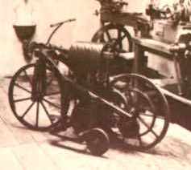
From the past . . . .
The first motorcycle was designed and built by German inventors Gottlieb Daimler and Wilhelm Maybach in 1885. This motorized bicycle, with a pair of stabilizers, was one of the first ever petrol-powered vehicles, and it was known as the Reitwagen, which means riding car.
. . . . to the present.
The new 2015 Kawasaki Ninja bike has 300 horsepower and is set to have a top speed of some 270 miles per hour! You may think this is a racing bike; however, aside from “the kind of acceleration no rider has ever experienced before”, Kawasaki want this bike to be an all-round bike with “stability and performance”.
The Law
In order to obtain a full licence to ride any motorbike, a theory test must be passed, a Compulsory Basic Training Course taken and two practical test modules also must be passed. Thirty motorcyclists are killed or injured every day at junctions, but despite these facts, the only compulsory protective gear is a helmet (except for Sikhs wearing a turban who do not have to). Experienced riders will say “all the gear all the time” and novice riders should pay attention to this. Coming off a bike at 70 mph and sliding along a tarmac road will break numerous bones as well as slicing strips of skin from all exposed parts of the body causing severe scarring – if the rider is lucky enough to survive. Full leathers – jacket, trousers, boots and gloves – are advised for riding even the smallest of bikes.

Interesting Facts
A feeling of complete freedom is often given as the reason for loving motorbikes though the convenience factor should not be ignored; eight motorbikes can park in the same space as one car and a bike can often wiggle its way carefully through a long traffic jam.
Motorcycles are often used for display purposes, their daredevil riders showing great skills with death-defying stunts.
- The fastest ever wheelie – when a motorcycle is pulled up onto one wheel – was performed at 105 mph.
- Ten motorbikes supported a record pyramid of 201 men in India in 2001.

Motorbikes – Questions
- Pistons move . . in a circle left to right up and down

- Give the two ways you can control brakes on the motorbike.
- What year was the motorcycle invented?
1985 1885 1888 1855

- Why does the author write must in bold in the paragraph headed The Law? (1)
- What protective gear is recommended for riding a motorcycle?
- Why is “all the gear all the time” written in inverted commas?
- Who are exempted from wearing a helmet?
- What figure of speech is ‘ slicing strips of skin . . . causing severe scarring’?
- What is convenient about riding a motorcycle?
- How many motorbikes were involved in the record breaking pyramid?
- What kind of text is this and how does the writer make it easier to read?

Answers

- Up and down
- Hand levers and foot pedals
- 1885
- Emphasis –to make it stand out – so the reader sees it – important point
- Helmet, trousers, jacket, gloves, boots 2 pts for 4+ 1 pt for 2+
- It is what experienced writers say – speech – quote
- Sikhs wearing a turban do not accept Sikhs
- alliteration or sibilance
- Parking and wiggling through traffic jams
- 10
- Information text sub headings pictures bullet points 1 mark for each to 3

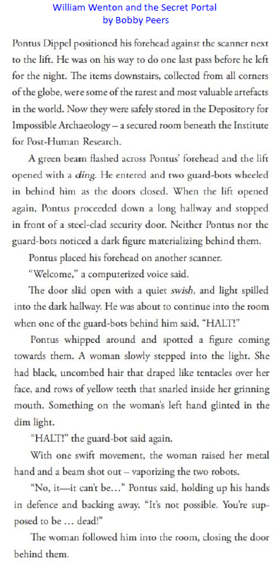
Friday
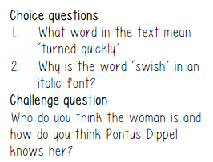
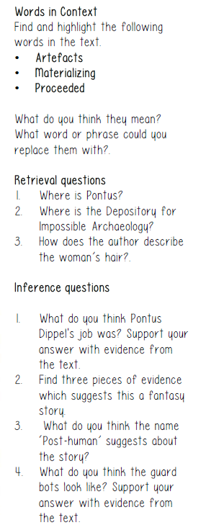
Questions

Retrieval
- Institute for Post Human Research
- A secured room underneath the institute
- Black, uncombed hair like tentacles.
Inference
- I think his job was an employee at the institute as in the text it says he made one last pass before he left for the night, showing he was locking up for the night.
- There was a green scanner used to open rooms, there was a computerized voice and there were guard-bots.
- It is set in the future when humans maybe do not exist anymore.
- I think they are robots on wheels as in the text it says they wheeled in behind him.
Choice
- Swift movement
- As it is a form of onomatopoeia so it is the same as the sound it would make.
Challenge
Answers may vary.

