Task 1
My Favourite Author
Write about your favourite author.
What to do…

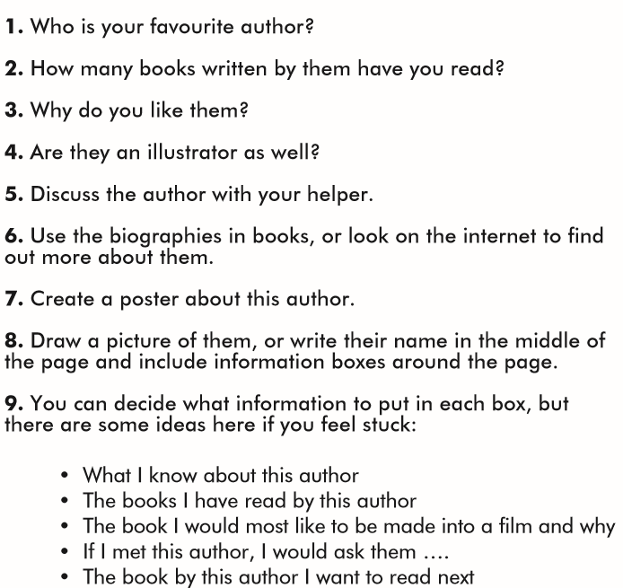

This is an example to help you:

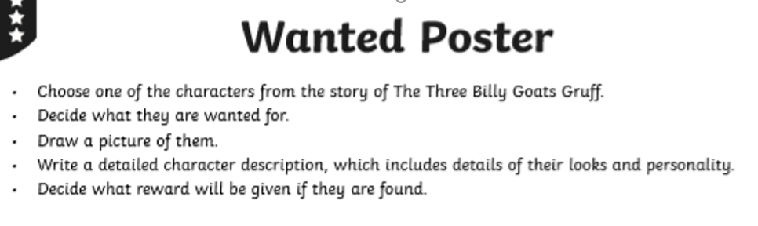
Task 2
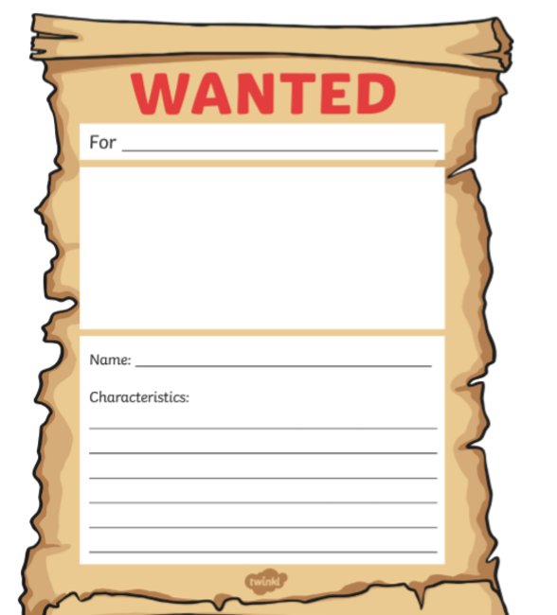
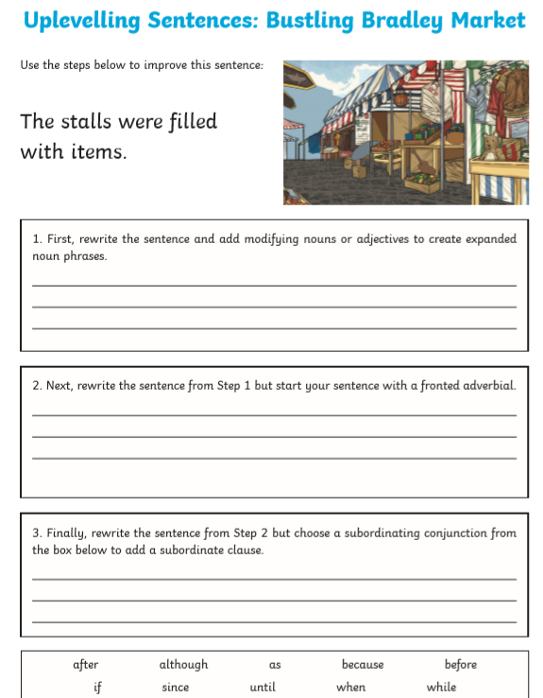
Task 3

Task 4
Which word is closest in meaning to the underlined word in each sentence?

1. The giant bellowed at the dragons as they flew overhead.
Circle one: looked waved smiled shouted

2. Jared and Rajesh devoured the asparagus cupcakes as fast as they could.
Circle one: planted squashed ate decorated

3. The witches chortled as the wizard tripped over his long dress.
Circle one: laughed argued screamed skipped

4. “You can’t go in there,” murmured Emily to her twin sister.
Circle one: whispered shouted giggled yelled

5. The cocky elf sauntered down the garden path.
Circle one: walked flew wrote cart-wheeled

6. The knight hopped down from on top of the king’s carriage.
Circle one: slipped shouted jumped nodded

7. Mabel chuckled at the ogre wearing a tutu.
Circle one: laughed waved aimed pointed

8. The captain snoozed in his hammock on the desert island.
Circle one: swayed dressed ate slept

9. The jester pranced in front of the King and Queen.
Circle one: laughed dressed danced worked

10. “The Green Knight is the victor!” proclaimed the King.
Circle one: announced muttered hissed asked
Task 5
Research a famous American landmark that you would like to visit. Can you create a poster persuading other tourists to visit?

